**Nov 2017 SL P1**

**Section A**

1. Identify **two** essential features of a computer language. [2]

*Award up to* ***[2 max]****.*

Fixed vocabulary;

Unambiguous meaning;

Consistent grammar;

Consistent syntax;

Provide a way to define basic data types and operations on those types (ability to write

functions/procedures);

Provide ability of Input and output handling;

Provide some kind of loop that can be stopped / conditional statement / branching

(conditional and unconditional branching);

It should have variables that reference computer memory, syntax for basic arithmetic

and logical;

Operations on those memory locations;

It has to run on/be able to be processed by a computer (*ie* it must have a

compiler/interpreter)

***Note:*** do not accept aspects that address interoperability/portability/standards/user

friendliness

1. Two fundamental operations of a computer are add and retrieve. State another **two**   
   fundamental operations. [2]

Compare (*accept* Check);

Store (*accept* Write / Save);

***Note:*** Accept the following wording for categories of operations

Input (Read);

Processing/execution (*eg* calculate, decode, fetch, delete, evaluate, sort, transfer,

transmit);

Output;

Control;

***Remark:*** *Beware of repetitions with the wording in the question paper, or repetitions*

*between the two given examples. Marks should not be awarded twice in those cases.*

*For example,*

*Search/look up, or comparable wording, are synonyms of the given Retrieve;*

*Insert/put, or comparable wording, are synonyms of the given Add;*

*Lists of repeated arithmetic operations that fall under examples of calculations (subtract,*

*divide, multiply, square) are all examples of calculations, and hence processing.*

1. In the context of a networked world, state the role of
2. a client. [1]

A piece of computer hardware or software that accesses a service made

available by a server /

The role of a client is to access a service made available by a server by sending

a request for service;

***Note****: the term client is to be understood only from the computing perspective, ie*

*this is not a human.*

1. a server. [1]

A program/host computer that awaits and fulfills requests from client programs (in

the same or other computers) /

The role of a server is to fulfill requests from client programs (which can reside in

the same or in other computers)

***Note****: the term server is to be understood only from the computing perspective,*

*ie this is not a human.*

1. Identify **one** method of inputting data that can improve the accessibility of a computer

system for some users. [1]

*Award up to* ***[1 max]****.*

Text-to-speech;

Voice recognition;

Braille keyboards;

Touch screen;

Input from scanner;

1. Copy and complete the following truth table. [3]

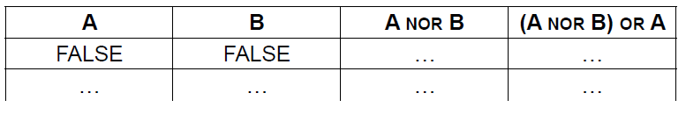

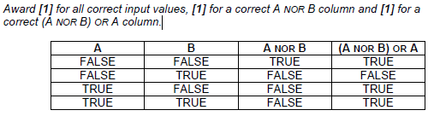

1. Construct a logic diagram for the Boolean expression

NOT A OR B AND C. [3]

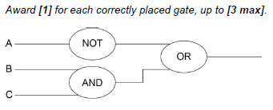

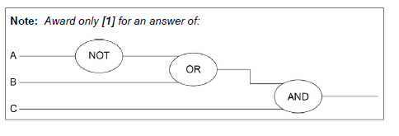

1. 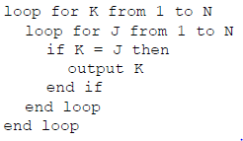Consider the following algorithm, where N is a positive integer

1. Determine the number of times the comparison K = J will be performed. [1]

N2

1. Determine the number of times the statement output K will be executed. [1]

N

1. Construct the algorithm which performs the same task using a single while loop,

instead of nested for loops. [4]

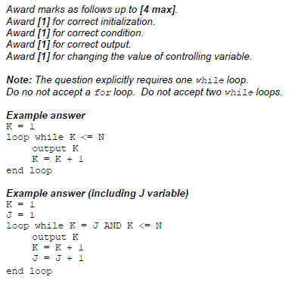

1. The machine instruction cycle is the process by which a program instruction is fetched,

decoded, executed and the results are stored.

1. State where all instructions and data are stored. [1]

Primary memory / RAM

1. Outline the role of the data bus and address bus in this process. [2]

*Award up to* ***[2 max]****.*

***Note****: there must be explicit reference to both address and data bus*

***Example 1***

Buses are used as physical connections to carry information to the CPU;

The data bus transports data from/to CPU, whereas the address bus the memory

address where the data is supposed to go/be.

***Example 2***

Data bus is a physical connection to transport data from-to CPU to be

processed;

Address bus is a physical connection to transport an address of memory storage where data

(transported in the data bus) should be read/written;

***Note:*** *Award* ***[1]*** *mark, for responses that show some understanding of use of*

*buses in CPU, for address location and data transport without using specialist*

*terminology*

1. Define the term bit. [1]

Binary digit;

(Minimal) unit of storage that can be set to 0 or 1;

1. Outline what is meant by beta testing. [2]

Involves sending sample software to the intended audience;

(Selected audience do not pay for this software);

To try/use the software product;

And give the feedback to the authors (which help in correcting bugs);

**Section B**

1. An application package used in an office includes a word processor. A secretary uses the

word processor to create a text file.

1. Describe how a spellchecker checks whether a word in a text file is correctly spelt

or not. [2]

Each word in the text file is compared with words in a dictionary (held in

memory/online);

If the word is found in the dictionary it is correctly spelt / if the word is not found in

the dictionary, spellchecker will recognize that it is incorrectly spelt;

The text file is automatically saved at regular periods while being edited.

1. State **one** advantage of this feature. [1]

*Award* ***[1 max]****.*

If power goes off, only the text typed after last (automatic) save is lost;

***NOTE:*** *accept responses that express evidence of just a partial loss of the file.*

1. Identify **two** additional features of a word processing package that could be useful for   
   this office. [2]

*Award up to* ***[2 max]****.*

Apply styles, effects;

Insert (tables/pictures/graphs/formulas/...);

Mail merge;

Macros;

Print;

*etc*.

1. Outline the purpose of **one** application software package other than a word processing

package that could be used in this office. [2]

*the office, up to* ***[2 max]****.*

Example answers:

Spreadsheet;

For graphically presenting various data;

Database software;

For holding employees/customers data;

Web page creators/editors;

To create/manage the office’s web pages;

etc.

All files created in this office contain information important to the business.

1. Outline the security measures that should be taken to prevent data loss. [2]

*Award up to* ***[2 max]****.*

Off site data storage;

Make backups regularly/periodically/frequently;

Prevent physical damage to the computers / Keep equipment in safe and dust free

places / Protect equipment from static electricity that can erase data or

damage components / Protection during lightning and electrical storms;

***Note:*** *Accept any reasonable examples, but there should be more than one.*

*The focus of the question is on data loss, and not in relation to*

*security/hacking.*

The office manager decides to buy and install new software and hardware.

1. Outline **one** problem that may arise from the installation of new hardware and software

in the office. [2]

*Award* ***[1]*** *for stating a problem and* ***[1]*** *for an elaboration, up to* ***[2 max]****.*

Users/employees might be afraid of these changes (for various reasons);

And not willing to help in this change;

Data migration problems;

For example, different file formats so conversion must be performed;

Employee efficiency may drop;

As they learn to use the new system;

Issue of compatibility with legacy software/hardware;

So features of new software/hardware may not work correctly;

The changeover to the new system can be achieved by either direct changeover or  
 phased conversion.

1. Compare direct changeover and phased conversion. [4]

*Award* ***[1]*** *for outlining what is meant by direct changeover,* ***[1]*** *for outlining what*

*is meant by phased conversion, and then* ***[1]*** *for an advantage or disadvantage*

***of each****, up to* ***[2]****.*

***Example answer:***

Direct changeover, the old software and hardware is completely replaced, in one

move, by the new software and hardware;

Phased conversion involves selecting one section in the office for the direct

changeover and other sections will be switched when the first section selected is

running satisfactorily. Eventually the whole office has been changed;

A phased conversion is less risky than a direct changeover as any problems that

might arise will be isolated in only one section in the office;

Direct changeover means everyone in the organization has same

software/hardware and so there are no compatibility issues;

1. A wireless local area network (WLAN) is used to extend access to a school’s wired

local area network.

1. Identify **one** hardware component of the WLAN, other than computers. [1]

*Award up to* ***[1 max]****.*

Wireless router/modem;

Access points;

Switch;

Wireless repeater/extender/booster;

The advantages of this WLAN are user-mobility and economical access points.

1. Outline **two** disadvantages of this WLAN. [4]

*Award* ***[1]*** *for identifying a disadvantage and* ***[1]*** *for an expansion, for* ***two***

*disadvantages up to* ***[4 max]****.*

Data transfer will decrease (compared with a wired LAN);

Because the number of computers using the network increases;

(and because) WLAN has lower bandwidth than a wired LAN;

Less data security;

As devices from outside the school can access the network/intercept

transmissions;

More easily open to misuse;

As teacher/administrator cannot directly monitor a specific student/teacher/

machine;

Intermittent connectivity due to physical barriers (walls);

Results in low transfer/speed and may hinder operations.

***Note:*** *Accept any reasonable points, provided they are appropriately*

*elaborated.*

1. Identify **three** ways in which the network administrator can reduce the risk of   
   unauthorized access to confidential data. [3]

*Award up to* ***[3 max]****.*

Give each user appropriate login details/passwords;

Different access rights for students, teachers, school administrators (file-level and

share-level security);

All passwords and files should be encrypted;

Use the latest WiFi protocol/WPA2;

Require MAC address authentication;

Password protect the documents;

***Note:*** *the focus of the question is on confidential data (firewalls not accepted)*

The concept of packet data transmission is used within this network. Figure 1 shows the   
 simplified structure of a data packet.

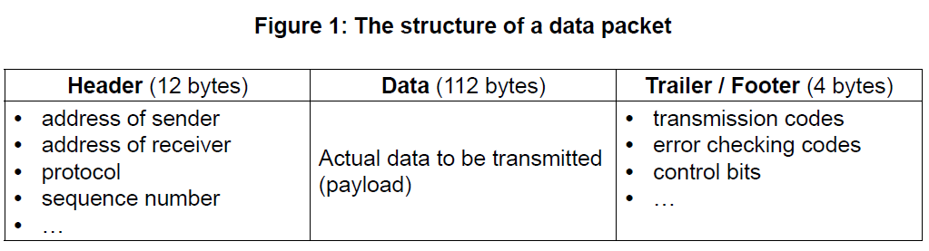

1. Define the term protocol. [1]

Set of rules for data transmission;

1. With reference to **Figure 1**, explain how data is transferred by packet switching. [6]

*Award up to* ***[6]*** *as follows:*

*Award up to* ***[3 max]*** *for a general description of how data is transferred by*

*packet switching. ([1 max] if this general description is very simplistic and refers*

*to just the Header/Data/Trailer already shown in the question paper).*

*Award up to* ***[3 max]*** *for added detail that references the contents of the given*

*data packet in the answer.*

***Example of general description***

Data is organized in specially formatted units (data packets) which are routed

from source to destination using network switches and routers;

Network switches and routers determine how best to transfer the packet between

a number of intermediate devices (routers and switches) on the path to its

destination (rather than flowing directly over a single wire on the path to its

destination);

Data packets are reassembled at the destination;

***Example of referencing content***

***Addresses*** have to be in a standard format so that each switch/routing station

recognizes the address;

***Address of sender*** identifies the sending computer, so that any packets not

received can be re-requested;

***Address of receiver*** identifies intended recipient so it can be forwarded on

correctly;

The ***protocol*** used must be identified so that the correct rules are followed;

***Size of packet / size of fields in packet*** – All packets/fields must have the same

size so that the data can be reassembled;

***Sequence number*** so that packets can be reassembled in correct order;

***Transmission codes*** to show whether the data packet is transmitted or

re-transmitted;

***Control bits****,* to maintain the integrity of the data by ensuring that the data

received is the same as the data sent;

***Error checking code*** – when an error is detected, an algorithm either corrects

the error or requests that the packet is resent;

1. A character array S holds the word “PSEUDOCODE”.



1. State the index of character “U” in the array S.

3

1. Consider the following algorithm. The function len() returns the number of characters

in an array (for example, len(S) is 10).

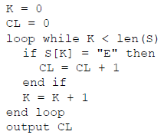

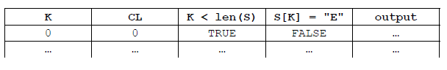 For this algorithm, complete the following trace table. [4]

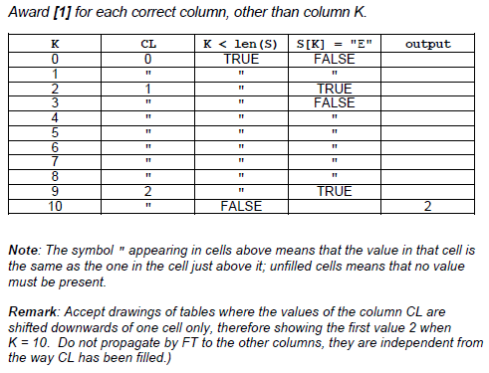

A simple method of encoding a message is to use substitutions to produce a cryptogram.

Given a positive integer N and the array UPCASELETTERS containing letters in alphabetical

order, a new array SUBSTITUTE is created by shifting the entire contents of UPCASELETTERS

to the left, N times. As an element moves off the left of the array, it moves back into the right

side of the array.

For example, given the array UPCASELETTERS:



When N = 5 the array SUBSTITUTE will be:



1. Construct an algorithm which creates the array SUBSTITUTE. You may assume that a

positive integer N and array UPCASELETTERS are given. [5]

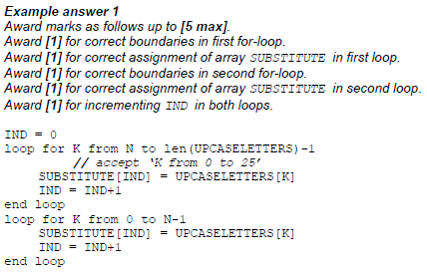

This encoding method produces a cryptogram of a sentence by replacing each uppercase  
letter of the sentence with its substitute. Other characters in the sentence are not changed.

For example, using the arrays shown on page 6:

Input (sentence): ARS LONGA, VITA BREVIS.

Output (cryptogram): FWX QTSLF, ANYF GWJANX.

The following algorithm fragment inputs the characters, one by one, from the input sentence,  
and outputs its cryptogram using the method encode().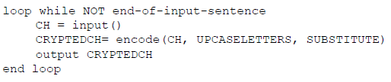



The method encode() accepts a character CH and two arrays UPCASELETTERS and

SUBSTITUTE, as defined above, and returns the corresponding character CRYPTEDCH of the

character CH.

1. Explain the steps to construct an algorithm for the method encode(). [5]

*Award up to* ***[5 max]****.*

Search the array UPCASELETTERS;

Using a linear/sequential or binary search;

Search for the position/index of character CH;

If CH is found in UPCASELETTER;

Return the value stored in the array SUBSTITUTE at this position/index;

Otherwise return CH;